Exp No:5 Data Collection and Initial Exploration
Aim:
To collect, load, and perform initial exploration of the diabetes dataset.
Description:
The diabetes dataset is loaded using pandas. The dataset is explored using head(), info(), and describe().Histogram are used to visualize the distribution of each feature.
Code:
import pandas as pd
import numpy as np
import matplotlib.pyplot as plt
import seaborn as sns
url = "https://raw.githubusercontent.com/jbrownlee/Datasets/master/pima-indians-diabetes.data.csv"
columns = [
'Pregnancies',
'Glucose',
'BloodPressure',
'SkinThickness',
'Insulin',
'BMI',
'DiabetesPedigreeFunction',
'Age',
'Outcome'
]
db = pd.read_csv(url, names=columns)
print(db.head())
print(db.info())
print(db.describe())
db.hist(bins=50, figsize=(20, 15))
plt.show()
sns.pairplot(db)
plt.show()
Output:
Pregnancies Glucose BloodPressure SkinThickness Insulin BMI \
0 6 148 72 35 0 33.6
1 1 85 66 29 0 26.6
2 8 183 64 0 0 23.3
3 1 89 66 23 94 28.1
4 0 137 40 35 168 43.1

DiabetesPedigreeFunction Age Outcome
0 0.627 50 1
1 0.351 31 0
2 0.672 32 1
3 0.167 21 0
4 2.288 33 1
<class 'pandas.core.frame.DataFrame'>
RangeIndex: 768 entries, 0 to 767
Data columns (total 9 columns):
# Column Non-Null Count Dtype
--- ------ -------------- -----
0 Pregnancies 768 non-null int64
1 Glucose 768 non-null int64
2 BloodPressure 768 non-null int64
3 SkinThickness 768 non-null int64
4 Insulin 768 non-null int64
5 BMI 768 non-null float64
6 DiabetesPedigreeFunction 768 non-null float64
7 Age 768 non-null int64
8 Outcome 768 non-null int64
dtypes: float64(2), int64(7)
memory usage: 54.1 KB
None
Pregnancies Glucose BloodPressure SkinThickness Insulin \
count 768.000000 768.000000 768.000000 768.000000 768.000000
mean 3.845052 120.894531 69.105469 20.536458 79.799479
std 3.369578 31.972618 19.355807 15.952218 115.244002
min 0.000000 0.000000 0.000000 0.000000 0.000000
25% 1.000000 99.000000 62.000000 0.000000 0.000000
50% 3.000000 117.000000 72.000000 23.000000 30.500000
75% 6.000000 140.250000 80.000000 32.000000 127.250000
max 17.000000 199.000000 122.000000 99.000000 846.000000

BMI DiabetesPedigreeFunction Age Outcome
count 768.000000 768.000000 768.000000 768.000000
mean 31.992578 0.471876 33.240885 0.348958
std 7.884160 0.331329 11.760232 0.476951
min 0.000000 0.078000 21.000000 0.000000
25% 27.300000 0.243750 24.000000 0.000000
50% 32.000000 0.372500 29.000000 0.000000
75% 36.600000 0.626250 41.000000 1.000000
max 67.100000 2.420000 81.000000 1.000000
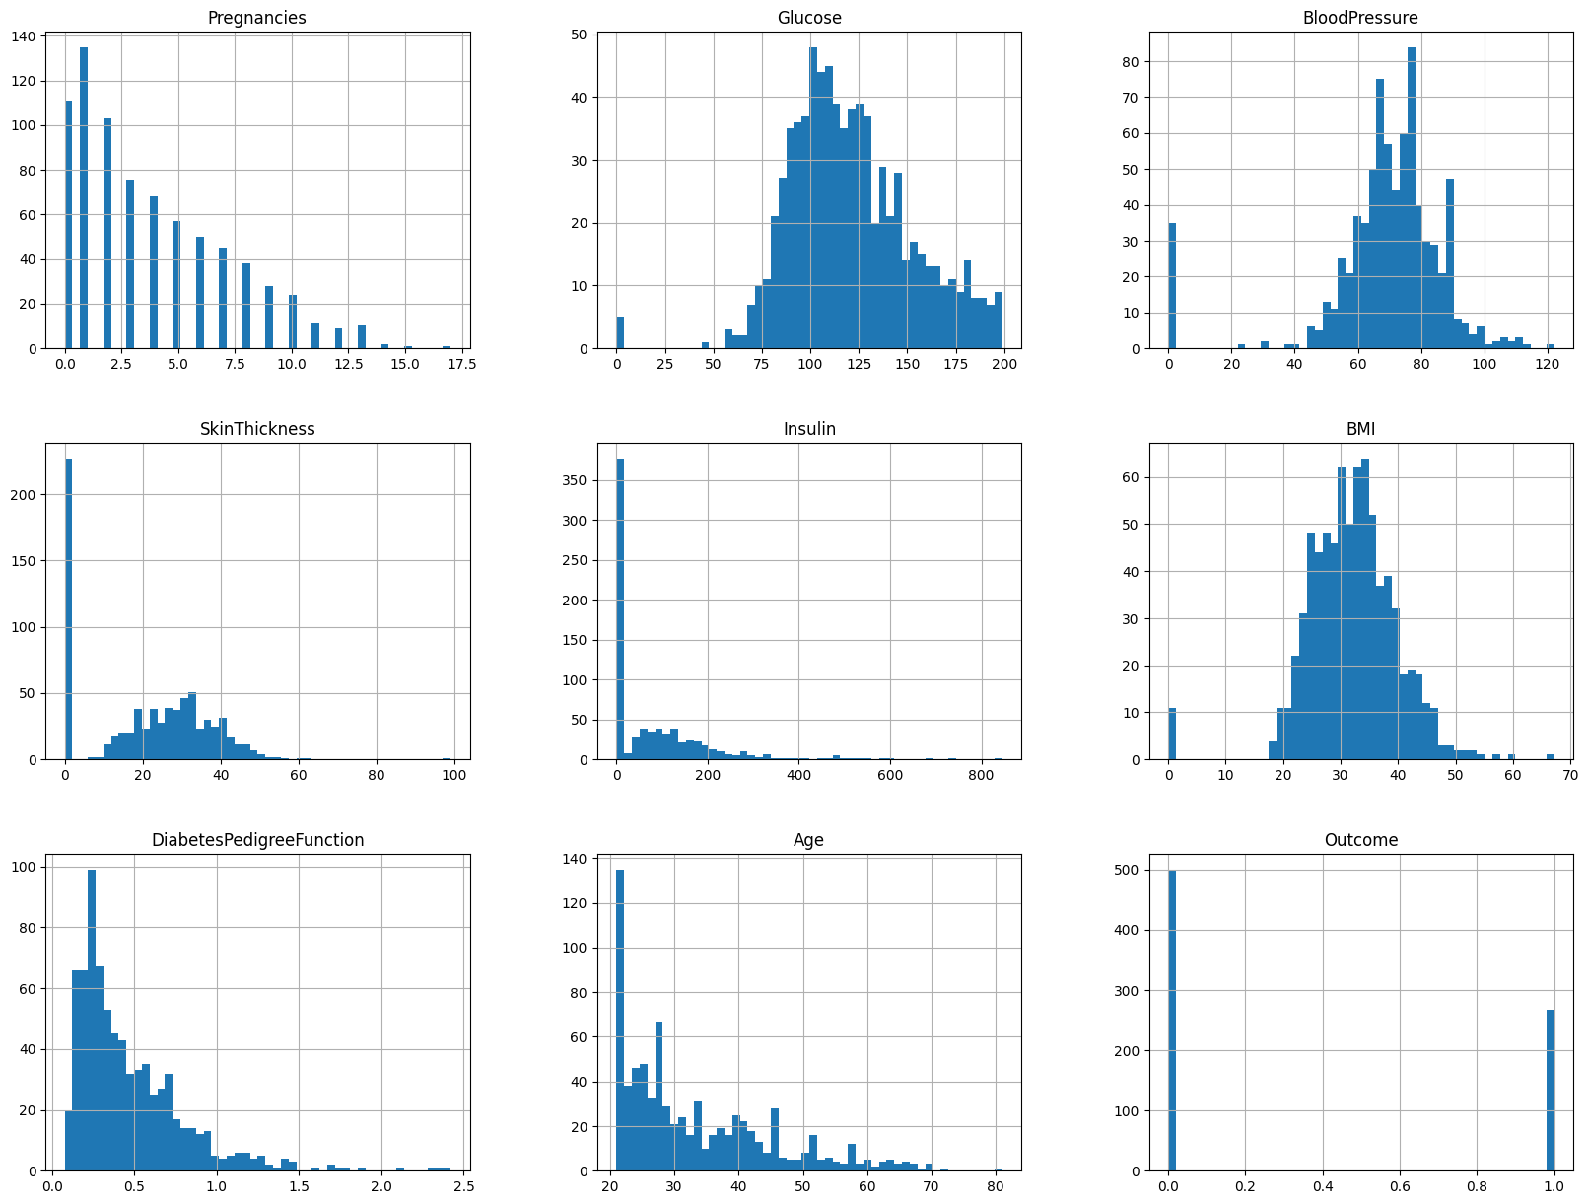
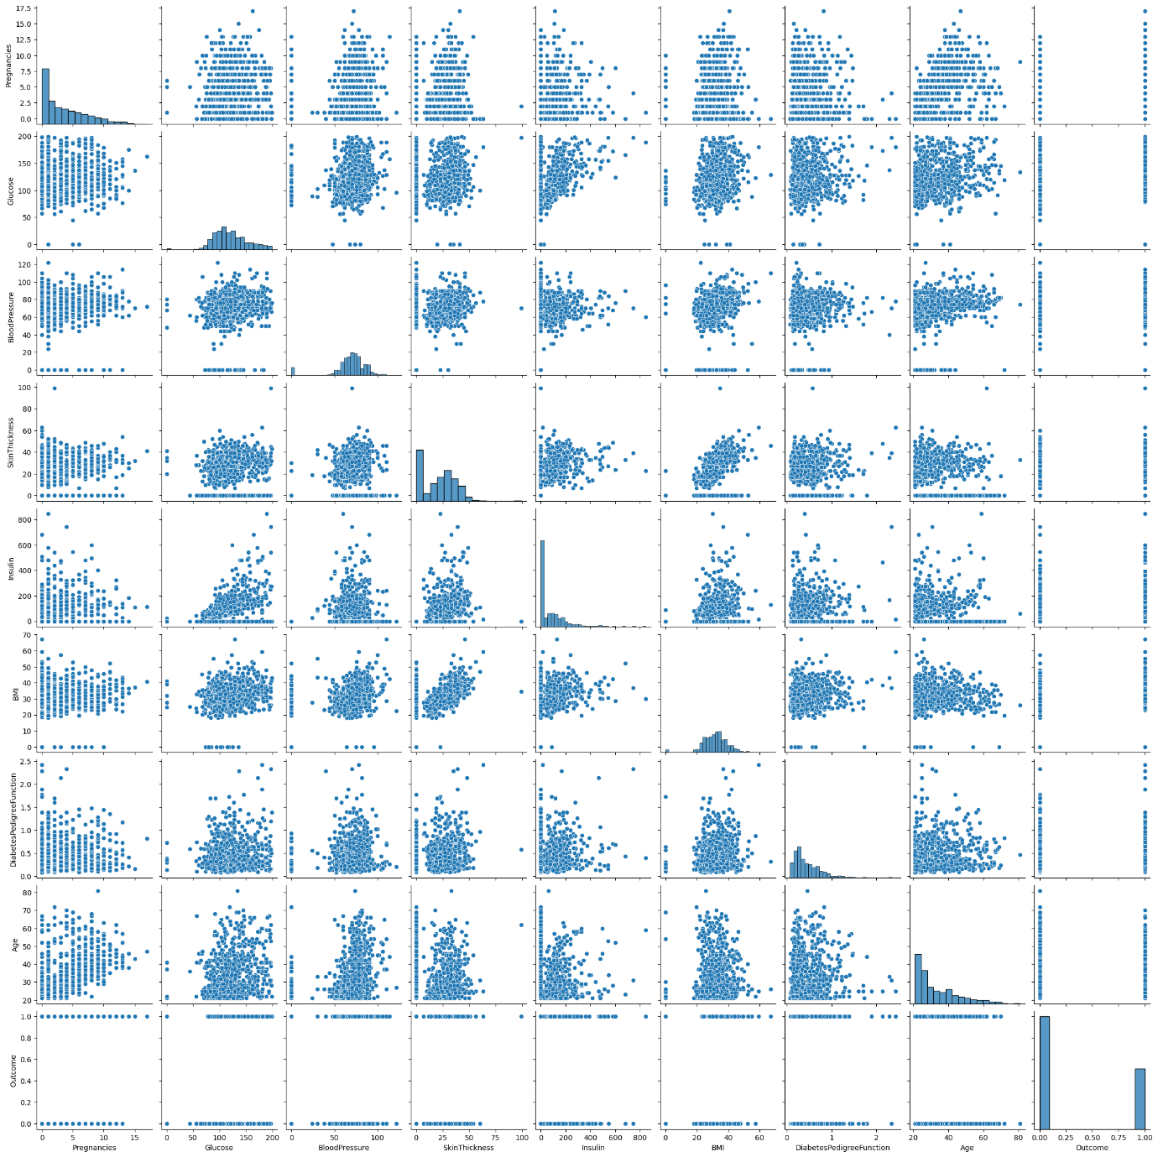
Result:
The diabetes dataset was successfully loaded and initially explored.the first few records,dataset,structure and summary statistics were displayed histogram showed the distribution of each features and the pair plot showed the relationship between the variables.

